|  |  |
| --- | --- |
| FINAL ACTION POINTS  Purchase of Project Saint  Healthcare Facility in Tokyo, Japan | ON BEHALF OF CLIENT:  Savills IM Asia Pacific Income & Growth Fund (“APACIG”) |

**“Project Saint” – St Catherine’s Hospital, Tokyo**

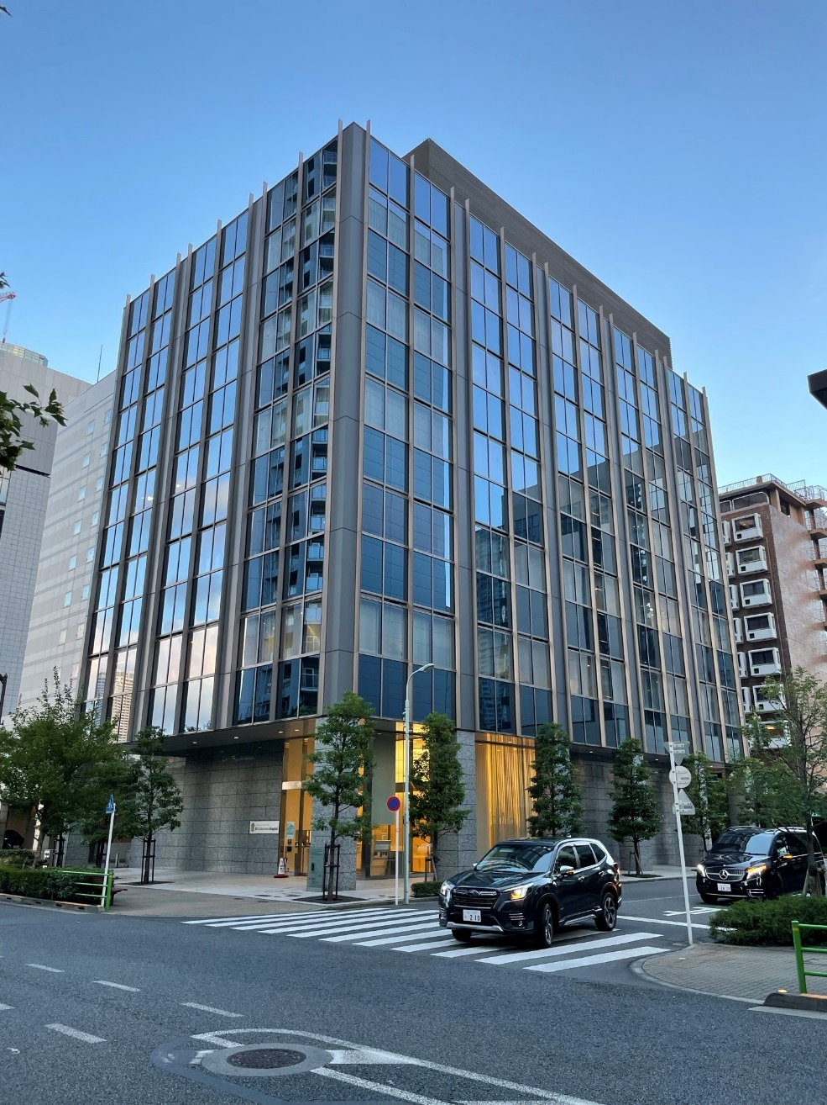

**Stage 3 Update**

Date of Issue: 27/3/2024, Version No. 1

# Final actions

No deal specific action items were identified during the Stage 2 meeting.

* 1. **Debt funding update**

After the Stage 2 IC, there was a revision in debt terms from the targeted lender, Aozora Bank, the existing lender of APAC 2 TMK (Project Yokohama-Kitasaiwai and Nishi-Gotanda), as a result of internal discrepancies within Aozora Bank’s lending department and risk management team.

Change in terms:

|  |  |  |
| --- | --- | --- |
|  | Stage 2 | Stage 3 |
| LTP / LTV | 65.0% LTP / 56.8% LTV | 61.1% LTP / 53.4% LTV |
| Loan Amount | JPY 2,158 mm | JPY 2,030 mm |
| Loan Term | 5.0-year term with 2.0-year tail period | 3.5-year term [with 1 or 2 year extension (TBD)] |
| Interest Rate | 1.15% spread over base rate  TONA swap rate with floor at 0% – for reference, 5-year TONA Swap priced at 52bps as of 8 Feb. 2024, 5-year forward starting TONA Swap from 30 April 2024 currently 56bps | 1.127% spread over base rate  Underwriting assumes 60bps base rate as conservative estimate. The base rate will be fixed two business days prior to closing, interpolated from the 3 and 4 year swap. |
| Upfront Fee | 1.0% | 1.0% |
| Amortization | 2.50% per annum in 4-5 year | 2.50% per annum from Year 4 |
| Release Price | 110% | 110% |
|  |  |  |
| DSCR Test | 2024.10~: 2.73x | 2024.10~: 3.045x |
| LTV Test | Before Harumi acquisition: 64.0%  After Harumi acquisition: TBD | TBD |
|  |  |  |
| Comments | | |
| A breach of DSCR/LTV test would result in cash trap, and then sweep after 2nd consecutive DSCR test breach or LTV test breach.  From Jan 2026 onwards, a breach of 4th consecutive DSCR test would require a mandatory prepayment of JPY200mm. This would be a one-off pay down; there would be no obligation to top up again in the case of any subsequent DSCR breach. There is no Event of Default for a DSCR breach even if continuous. | | |

|  |  |
| --- | --- |
| **ISSUE / ADVISOR COMMENT** | **ACTIONS / TIMESCALE / COST** |
| Debt exit costs | |
| Under the fixed base rate assumption, breakage fee will apply if exiting the deal prior to maturity of the loan.  See Forecast Returns and Sensitivity section below for indicative breakage costs under the base-case scenario. | Breakage fee cost methodology:  → BFC= Loan Amount x (Base Rate - Lender’s investment yield at prepayment) x Remaining Period |
| Interest rate hedge | |
| N/A | Fixed rate debt |
| Currency hedge | |
| EUR and USD equity to be fully hedged against JPY using FX forwards. Benefit of hedging prudently assumed to be 0% per annum in underwriting. | FX hedging quotes from SEB to be benchmarked using Bloomberg and BARX trading platform. |

* 1. **Confirmation of Forecast Returns and Sensitivity**

The change in forecasted returns relating to the amended debt assumptions are outlined below.

**Impact on returns:**

|  |  |  |  |
| --- | --- | --- | --- |
|  | **STAGE 2**  **FORECAST** | **FINAL FORECAST** | **COMMENT** |
| Hold Period | 48 months | 42 months | Base-case assumption |
| Leverage | JPY 2,158mm  65.0% LTP  56.8% LTV | JPY 2,030mm  61.1% LTP / 53.4% LTV | Total; Debt from Aozora; valuation from JLL | |
| Equity Funding | JPY1,264mm | JPY1,379mm | Total | |
| Asset level  Hold period total return | 16.92% | 15.34% | Net, levered; Inclusive of C-tax recovery, before on-shore AM fees | |
| Fund level  Hold period total return | 15.85% | 14.47% | Net, levered; Inclusive of C-tax recovery (pre-promote) |
| Fund level  Hold period equity multiple | 1.74x | 1.66x | Net, levered; Inclusive of C-tax recovery (pre-promote) |
| Avg. Fund level net levered yield | 6.16% | 5.36% | Net, post tax and fees (pre-promote) | |
| Net Initial Yield | 4.39% | 4.40% | NOI/GPP, Day 1 |
| Going-in NOI Cap Rate | 4.60% | 4.60% | NOI/NPP, Stabilized basis |
| Exit NOI Cap Rate | 3.80% | 3.80% |  |
| **OTHER** | | | | |
| Please see appendix for sensitivities.* | | | | |

*Downside case assumes the base rate moves out 30 bps before the closing timing, which is currently considered an extreme movement.

# Conclusion and Final Recommendation

The Transaction Sponsors request that the IAC endorse our recommendation to proceed with the acquisition for the Asia Pacific Investment and Growth Fund under the conditions outlined herein.

|  |  |  |
| --- | --- | --- |
| Transaction Sponsor  (Fund Manager) | Transaction Manager | Fund Finance Manager |
| Greg Lapham | Will Johnson  Takaaki Watanabe | Ken Shimamura |

**Stage 3 Appendices**

**1) Sensitivities (stand-alone basis)**

***Base case scenario – Fund-level returns (post tax, post-fees)***



***Downside scenario 1: +30bps on base rate – Fund-level returns (post tax, post-fees)***

